**Practical 8**

**SQL queries to implements various mathematical functions on different data set and table data**

**Table used in theses queries.**

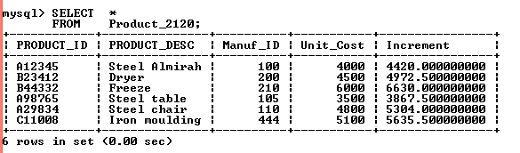

**Query1. Write a SQL query to use ROUND() mathematical function in this table.**

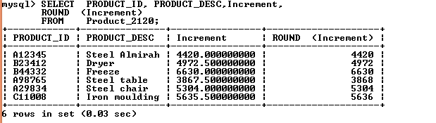

**Query2. Write a SQL query to use TRUNCATE () function in this table.**

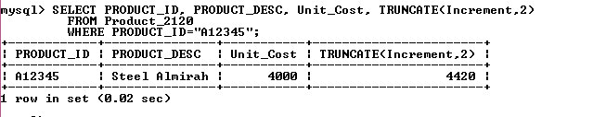

**Query3. Write a SQL query to use POW() in product_2120 table.**

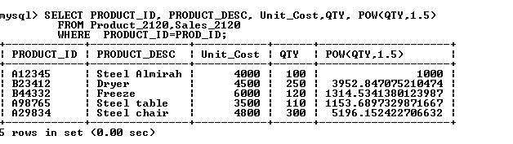

**Query4. Write a SQL query to use SQRT() mathematical function in Product_2120, Sales_2120 table.**

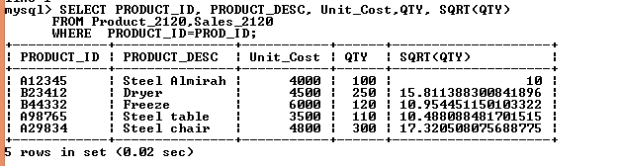

**Query5. Write a SQL query to use FLOOR(), CEILING() in the Product , Sales_2120 table.**

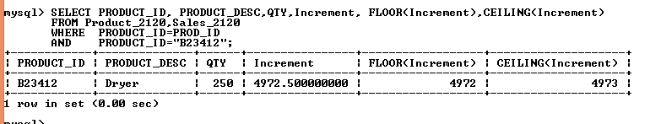

**Query6. Write a SQL query to use TAN() mathematical function in Product, Sales_2120 table.**

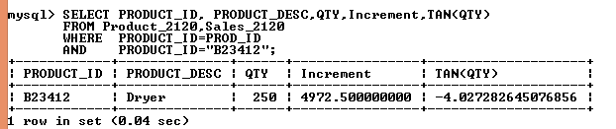

**Query7. Write a SQL query to use COS() mathematical function in Product, Sales_2120 table.**

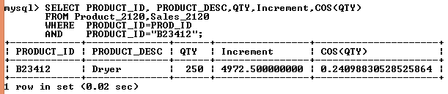

**Query8. Write a SQL query to use SIN() function in Product, Sales_2120 table.**

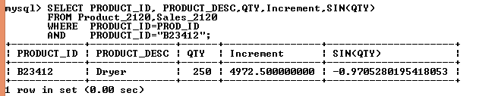

**Query9. Write a SQL query to use SIGN () function in Product, Sales_2120 table data.**

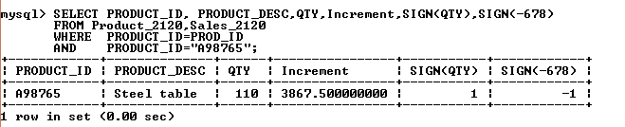

**Query10. Write a SQL query to use ABS () in the Product, Sales_2120 table data.**

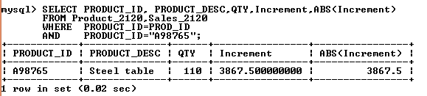

**Query11. Write a SQL query to use ROUND() in table to find the GST of Increase salary.**

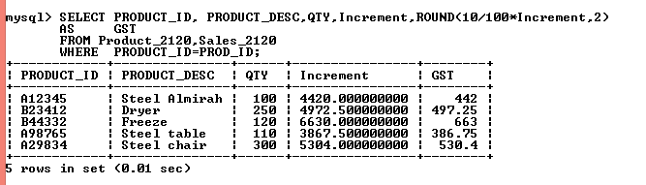

**Query12. Write a SQL query to use MOD(), ROUND() function in the Product, Sales table.**

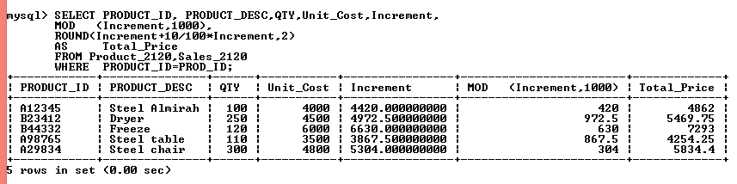**Query13. Write a SQL query to use DEGREES () in table Product_2120.**

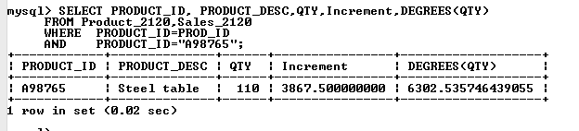

**Query14. Write a SQL query to use RAND() in the table Product_2120, Sales_2120.**

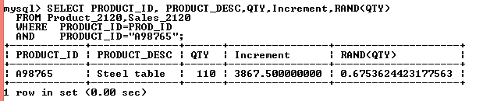

**Query15. Write a SQL query to use LOG, LN () function in Product, Sales_2120 table data.**

